mUUvies Spring 2025

January 9, 2025

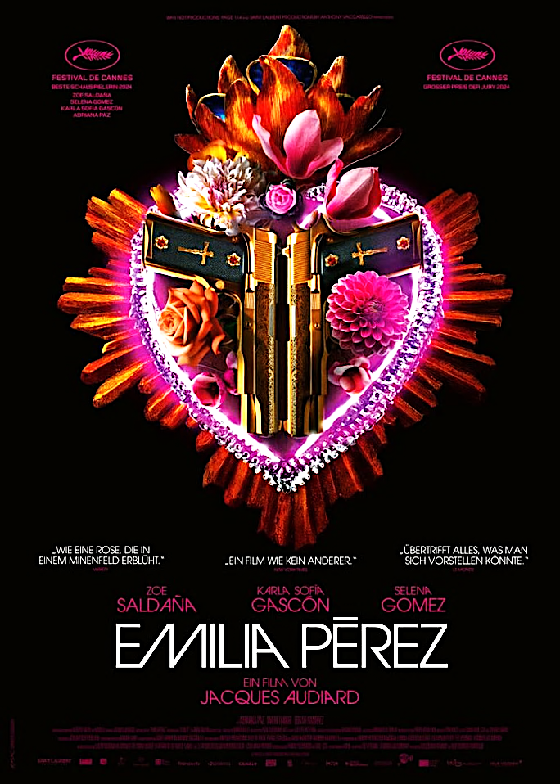

**Emilia Pérez** Net​flix 2024 Cannes Jury and Best Actress Prizes. A genre-bending comedy, a musical and a crime drama, Stunning, spectacular visuals, incredible choreography, great music​ amd dancing. Story of a feared ugly Mexican cartel kingpin who enlists a lawyer to achieve their transformation to a beautiful woman​ by help​ing to fake ​their death so that ​they can finally live authentically as her true self. Trans actress Karla Sofia Gascon was the first Trans wom​an to be nominated at Cannes in the Best Actress category. The power of family. ​

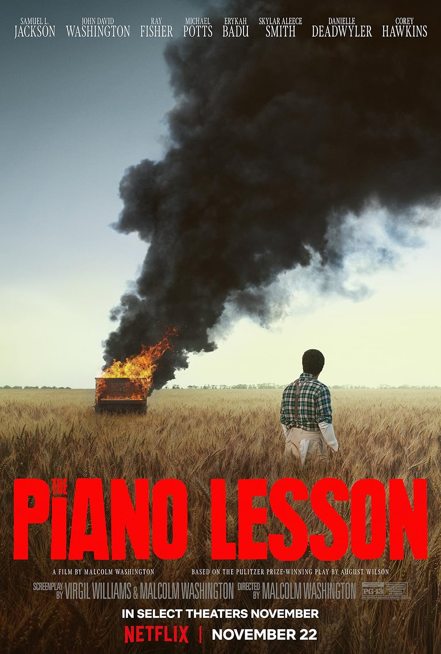

February 13, 2025

**The Piano Lesson** A fight over an heirloom piano stirs up ghosts of the past in this adaptation of August Wilson's Pulitzer-winning play. Produced by Denzel Washington; starring John David Washington and Samuel L. Jackson. The story centers on the conflict between siblings Berniece and Boy Willie Charles, descendants of a family with a painful history of enslavement, as they grapple with the fate of a priceless heirloom—a piano adorned with intricate carvings depicting their family’s lineage. Available on Netflix.

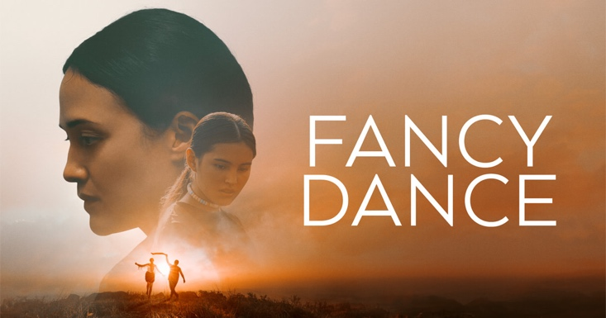

**March 13, 2025**

**Fancy Dance**  directed by Erica Tremblay; Since her sister's disappearance, Jax has cared for her niece, Roki, by scraping by on the Seneca-Cayuga reservation in Oklahoma. Every spare minute goes into finding her missing sister while also helping Roki prepare for an upcoming powwow. They defy the law and hit the road on a journey to the Grand Nation Powwow in Oklahoma City in hopes of keeping what is left of their family intact. Available on Apple TV+.

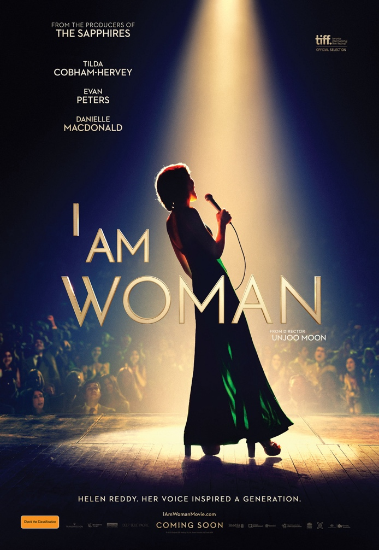

April 10, 2025

**I Am Woman** about the life of Helen Reddy. A 2019 [biographical film](https://en.wikipedia.org/wiki/Biographical_film) directed and produced by [Unjoo Moon](https://en.wikipedia.org/wiki/Unjoo_Moon). In 1966, Helen Reddy arrives in New York City to record an album, the result of her having won a contest in her home country of Australia. She meets with the [record label](https://en.wikipedia.org/wiki/Record_label), only for them to renege on the deal, leaving her stranded with her three-year-old daughter Traci. Lonely and in need of money, Reddy begins singing at small nightclubs. Netflix



May 8, 2025

**American Symphony** Director Matthew Heineman. In this deeply intimate documentary, pop musician Jon Batiste composes a symphony as his wife, writer Suleika Jaouad, undergoes cancer treatment. As polymath Jon Baptist rehearses with an orchestra for his symphony’s debut at Carnegie Hall his life is filled with accolades after getting 11 Grammy nominations. “*American Symphony* uses its behind-the-scenes access to present a portrait of courage and creativity”. Available on Netflix

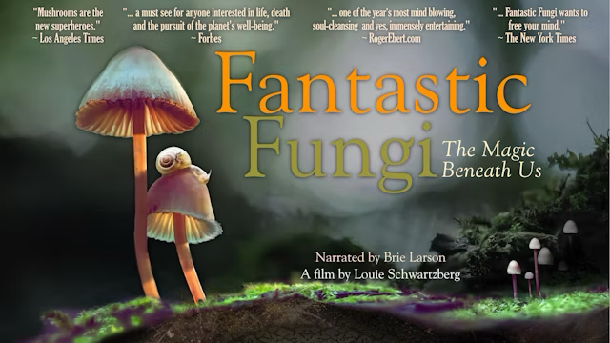

June 12, 2025s

**Fabulous Fungi** (a film about mushrooms) Documentary 2019 Directed by [Louie Schwartzberg](https://en.wikipedia.org/wiki/Louie_Schwartzberg). The film combines time-lapse [cinematography](https://en.wikipedia.org/wiki/Cinematography), [CGI](https://en.wikipedia.org/wiki/Computer-generated_imagery), and interviews in an overview of the [biology](https://en.wikipedia.org/wiki/Biology), environmental roles, and various uses of [fungi](https://en.wikipedia.org/wiki/Fungi). "As visually dazzling as it is thought-provoking, Fantastic Fungi sets out to make audiences see mushrooms differently -- and brilliantly succeeds." Netflix